RAINBOW KIDS AFTERCARE 2025/2026
Persoonlike Inligting van Leerling:
Personal details of learner:
Naam/Name:
Van/Surname:
Klas/Class:
Geboorte Datum/ Date of Birth:
Allergieë/Allergies:
Spesiale Behoeftes /Special needs:
Inligting van Ouers / Voogde:
Details of parents/guardians:
Vader se Inligting  Father’s details |  | Moeder se Inligting  Mother’s details
Naam / Name |  | Naam / Name
Van / Surname |  | Van / Surname
ID Nommer / IDNumber |  | ID Nommer / ID Number
Sel Nommer / Cell number |  | Sel Nommer / Cell number
Woon Adres / Physical Address |  | Woon Adres / Physical Address
Pos Adres / Postal Address |  | Pos Adres / Postal Address
Werkgewer / Employer |  | Werkgewer / Employer
Werk Nommer/ Work Number |  | Werk Nommer / Work Number

Mediese Inligting / Medical details
Mediese Fonds / Medical Aid
Fonds nommer en Plan Naam / Member number and Plan name
Huis Dokter / House Doctor
Dokter se kontak nommer / Doctor’s tel.nr
Naasbestaande ingeval van Nood (Indien ouers nie bereik kan word nie):
Next of kin, in case of an emergency (if parents can’t be reached):
Naam en Van / Name and Surname
Verband tot leerling / Relationship to learner
Kontak nommer / Contact number
Naam en Van / Name and Surname
Verband tot leerling / Relationship to learner
Kontak nommer / Contact number
Vervoer na en vanaf Rainbow kids Nasorg:
Transport to and from Rainbow kids Aftercare:
Dui asseblief aan wie die gereelde persoon verantwoordelik is vir die vervoer van u kind/kinders na en vanaf Rainbow Kids Nasorg. Slegs aangetekende lede sal hul mag kom optel, tensy vooraf gerëel is dat iemand anders hul kom optel.
Vervoer Metode : ____________________________________________________________________
(Verskaf asb naam en nommer indien dit nie een van die ouers is soos bo genoem.)
Please indicate the person who will be responsible to pick up your child from the aftercare at Bana. Only the person named below may come and collect your child, unless other arrangements were made with the aftercare teacher.
Method of transport: _________________________________________________________________
(Please provide us with the person’s name and number if it is not the parents or people named above.)

Handtekening van Ouers/ Voogde
Signature of Parents / Guardians:
Vader / Father: ___________________
Moeder / Mother: __________________ Datum / Date: ___________________

RAINBOW KIDS NASORG REëLS / RAINBOW KIDS AFTERCARE RULES
- TARIEWE / TARIFFS:
  - Maandelikse fooi vir Nasorg/ R850 per maand /per month
Monthly fee for aftercare:
(Bana leerders/learners 3-6 jaar/years) Dit sluit normale nasorg in vir kleuters vanaf 3-6 jaar. Includes aftercare for learners from 3-6 years old.

  - Metode van Betaling:

Baie welkom by Rainbow kids nasorg 2026. Nasorg fooie is betaalbaar van Januarie tot November (of vanaf die maand waarin die leerder aansluit tot en met November) ongeag hoeveel skooldae in daardie maand is. As u van vakansiesorg gebruik maak, betaal u daardie maand se volle fooi waarin die vakansie is en vakansie dae ekstra indien leerder dae in vakansie bywoon. Maande waarin skoolvakansies val, is steeds betaalbaar. U kan nie u kind vir daardie maand tuishou en dan weer later stuur nie. Vakansiesorg moet asb. vooraf (voor skool sluit) gereël word met juffrouens.
Welcome at Rainbow kids aftercare 2026. Aftercare fees are payable from January until November (or from the month that your child started until November) no matter how many days there are in the month. If you make use of our school holiday care, you will pay that month’s fee in full and the days used during the holidays extra. The month where there are school holidays must be paid. Learner may not be taken out for that month and brought back the next. Holiday care must be arranged in advance (before the school closes).

Betaling geskied stiptelik voor die begin van elke maand. Geen kind sal toegelaat word indien sy fooie nie betaal is nie. Payments are strictly payable in advance each month. No child will be allowed if fees are outstanding.

Betaling kan by juffrou aan diens of oor die internet in die onderstaande rekening gedoen word. Payments can be made at the teacher on duty or via internet banking to the following account:
Account naam: Yolanda Claudia Mienies
Bank: Capitec
Account Nr: 1451391054
Branch code: 470010
Reference: Gebruik asb u kind se naam en van as verwysing.
Please use your child’s name and surname as reference
- NASORG TYE /AFTERCARE HOURS:
Nasorg tyd is Maandae tot Donderdae vanaf 12:30 tot 17:00 en Vrydae 12:30 tot 16:00. Na sluitingstyd sal daar ‘n boete van R10 per 10min gehef word. Aftercare hours is Mondays – Thursdays from 12:30 to 17:00 and Fridays 12:30 to 16:00. Any children who are collected later than closing time, will receive a fine of R10 for every 10mins late.
Publieke Vakansie dae / Public holidays:
Geen nasorg sal beskikbaar wees op publieke vakansiedae nie. Aftercare is not open during public holidays.
Skool Vakansies / School holidays:
Nasorg sal wel tydens die skool vakansies van Maart, Junie/Julie, September en eerste 2 weke van Desember beskikbaar wees.
R70 per kind per dag vir een dag ‘n week.
R60 per kind per dag vir 2 dae per week.
R50 per kind per dag vir 3 tot 5 dae per week.
Vakansie nasorg moet asb vooraf bespreek en betaal word.

Aftercare will be open during the March, June/July, September holidays and only the first 2 weeks of December.
R70 per child per day for 1 day a week.
R60 per child per day for 2 days a week.
R50 per child per day for 3-5 days a week.
Aftercare during the school holidays must be arranged and paid beforehand.

Rainbow kids Nasorg kan nie verantwoordelik gehou word vir enige beserings onder toesig nie. Die ouers van die kind/kinders by die nasorg onderneem ook om enige skade deur u kind/kinders aan die perseel of toerusting van Bana te vervang wat deur u kind/kinders beskadig mag word. Rainbow kids Aftercare can’t be held accountable for any injuries during care. Parents will be responsible to replace any damage caused by your child to Bana property and equipment.

Indien u u kind uit Rainbow kids Nasorg wil onttrek, moet ouers een maand skriftelike kennis gee, waarna ouers steeds verantwoordelik sal wees vir die maand se klasgeld. When you want to take your child out from Rainbow kids Aftercare, you must give a month’s notice and are still accountable for that month’s fees.
Signature/Handtekening: __________________

Voel asb vry om direk met die betrokke nasorg onderwyser te gesels. Please feel free to contact the aftercare teachers directly.

Kontak Besonderhede van Nasorg Onderwysers / Contact details of Aftercare teachers:
Nasorg HOOF: Yolanda Mienies: 078 2455 822

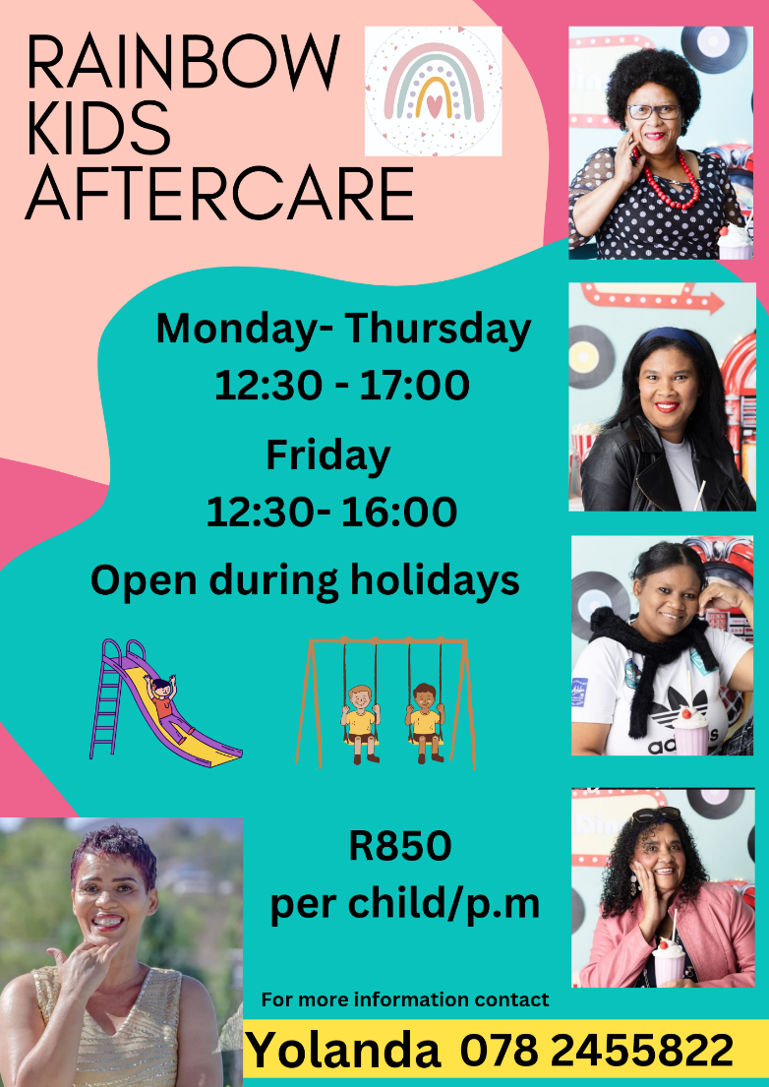
Juffrou Gloricia Dibe: 079 4571 555

Juffrou Yolandi Mouwers: 072 1536 108
Juffrou Christine Swartz: 078 1873 354

Juffrou Aida Bezuidenhout: 063 8680 869

